Module Name: Login Page
Test Case ID: 183
Webpage URL: https://practicetestautomation.com/

● Scenario ID: 10a
Scenario: Valid Login
Test Steps:
- Open the Login page
- Enter valid username
- Enter valid password
- Click Login
Screenshots:-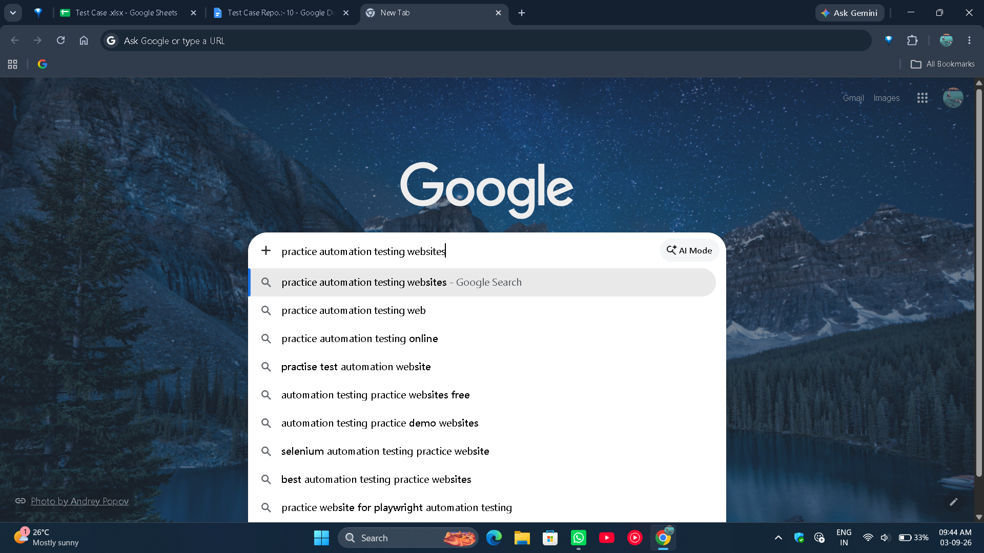

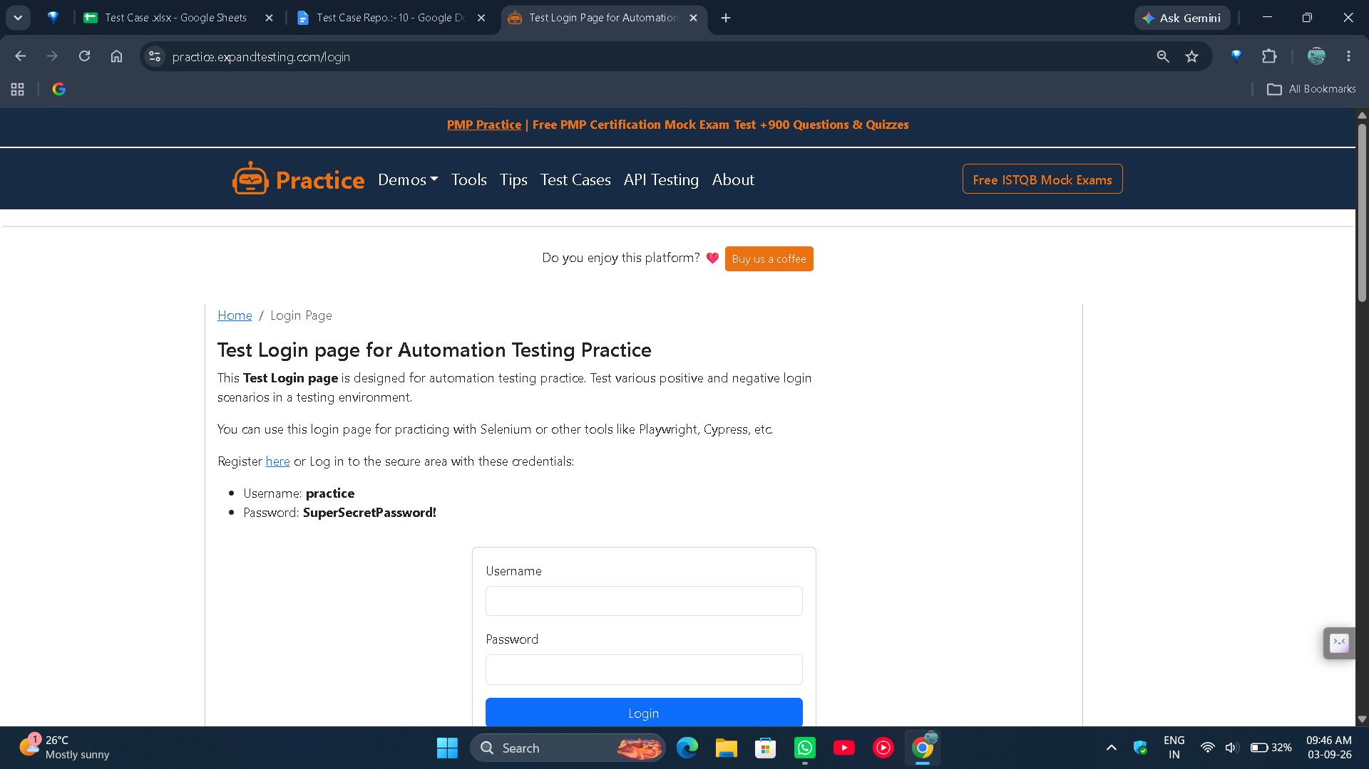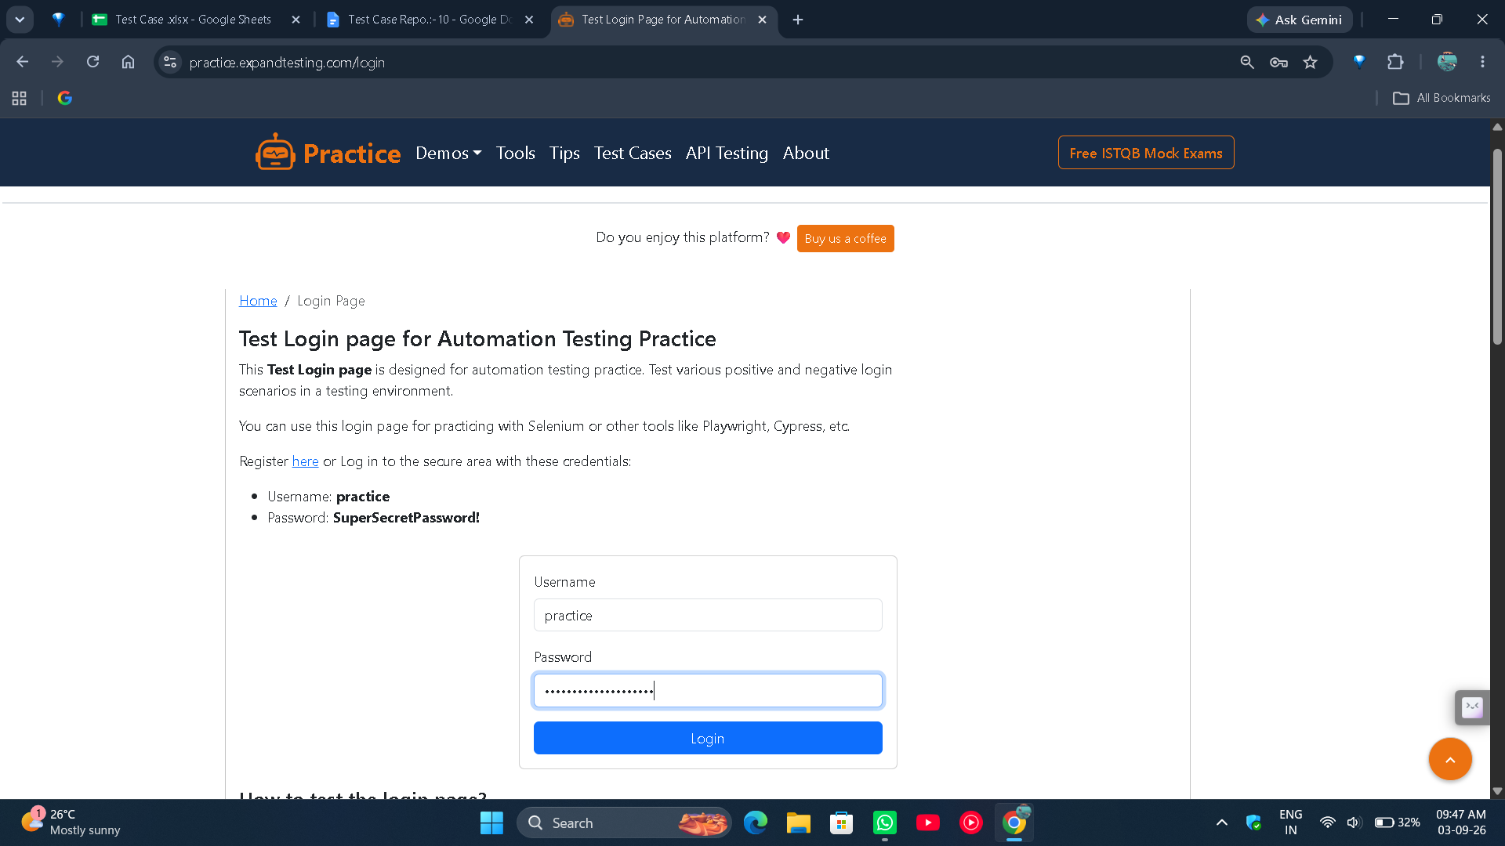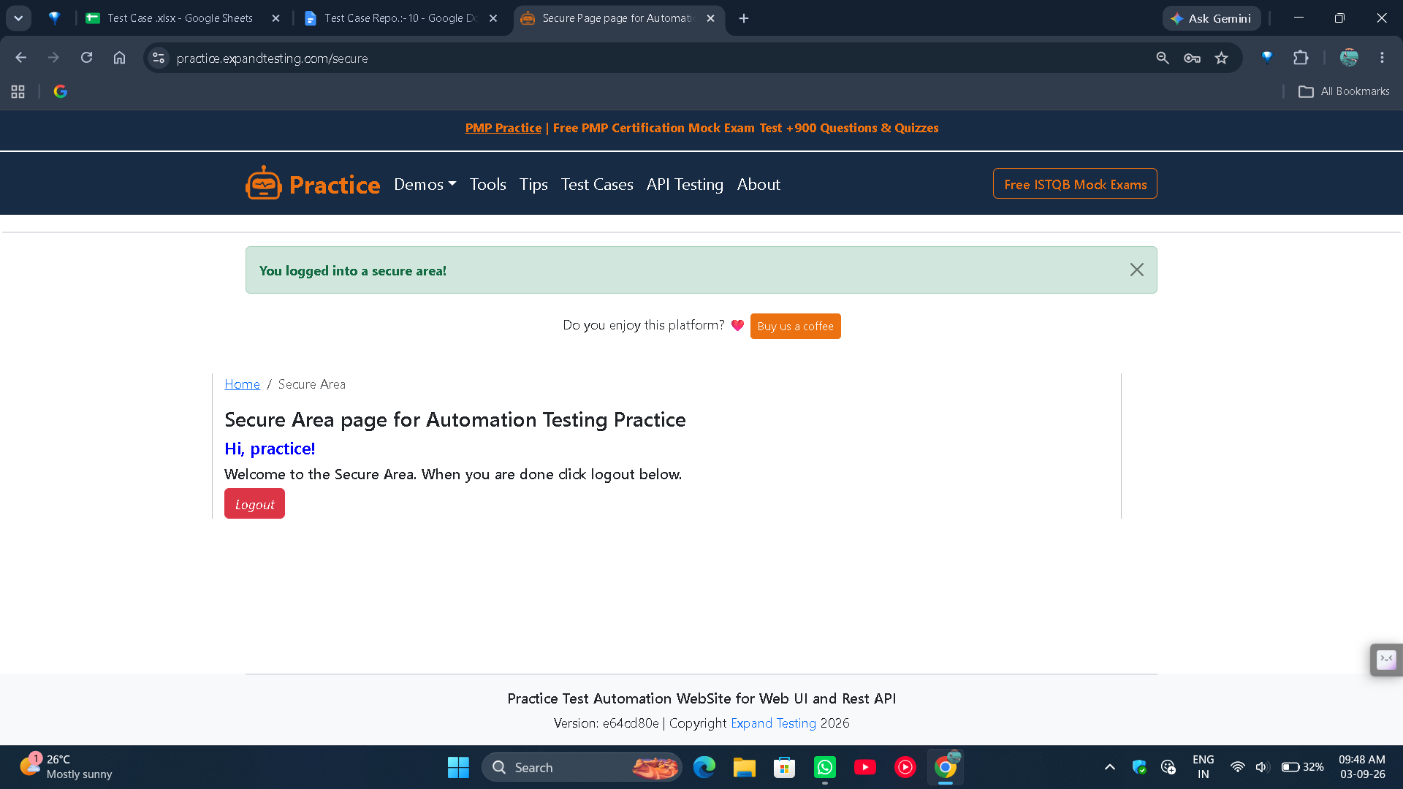
● Scenario ID: 10b
Scenario: Invalid Login
Test Steps:
- Open the Login page
- Enter invalid username
- Enter valid password
- Click Login
Screenshots:-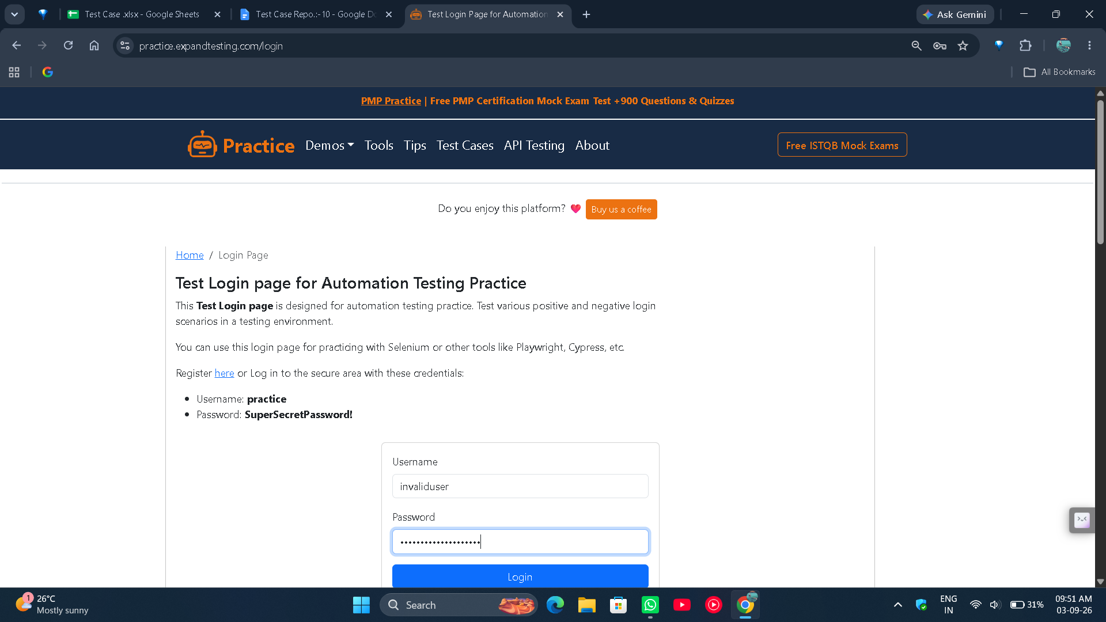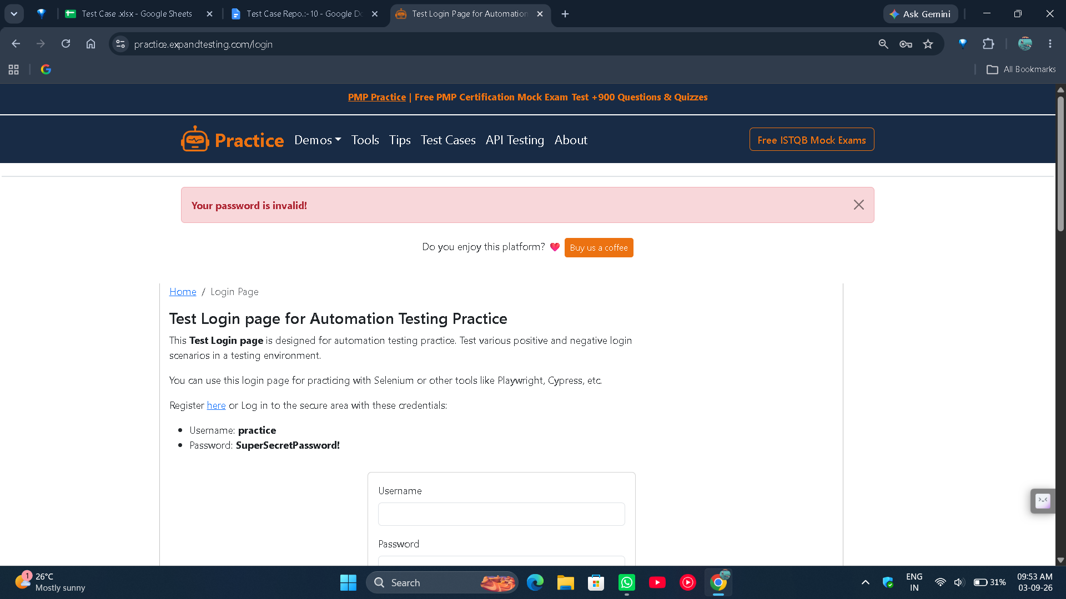

● Scenario ID: 10c
Scenario: Invalid Login
Test Steps:
- Open the Login page
- Enter valid username
- Enter invalid password
- Click Login
Screenshots:-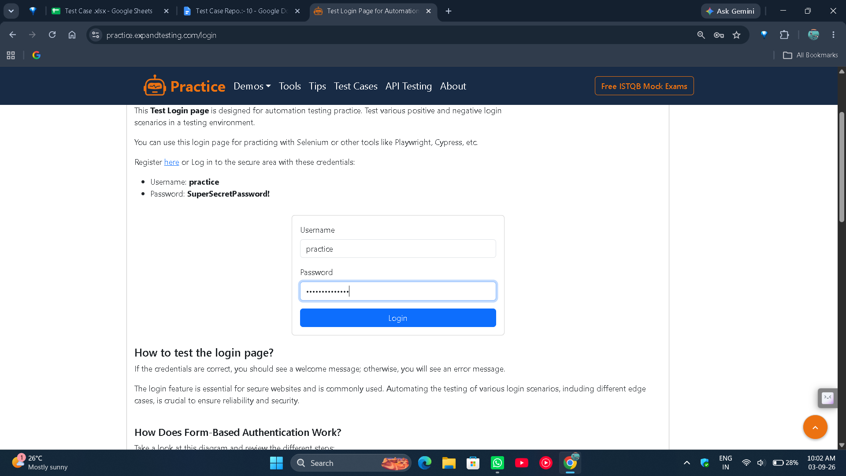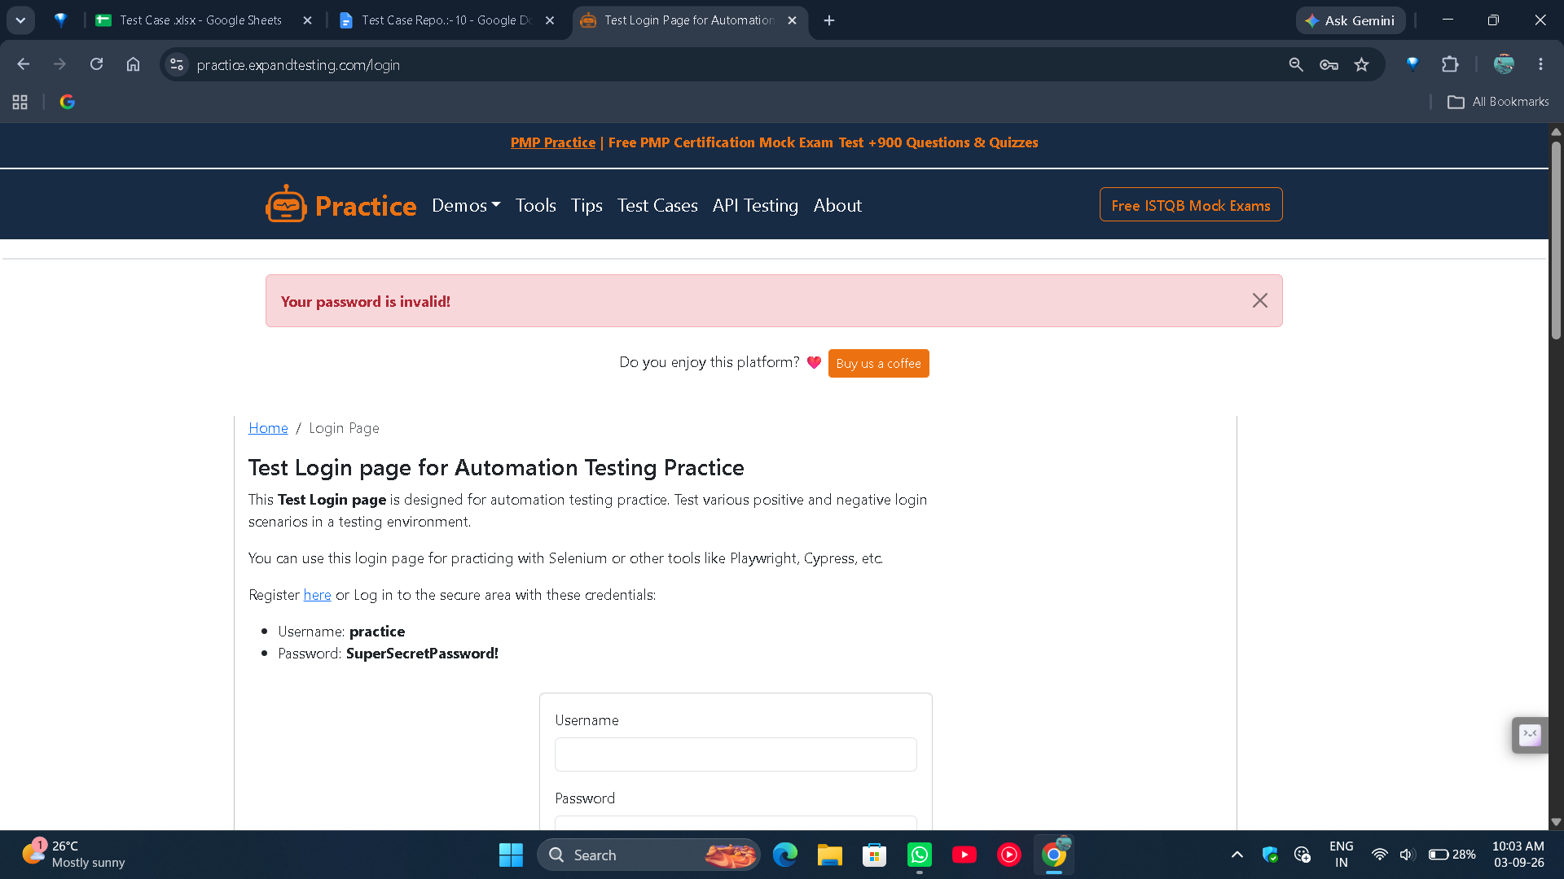

● Scenario ID: 10d
Scenario: Empty Credentials
Test Steps:
- Open the Login page
- Leave blank username
- Leave blank password
- Click Login
Screenshots:-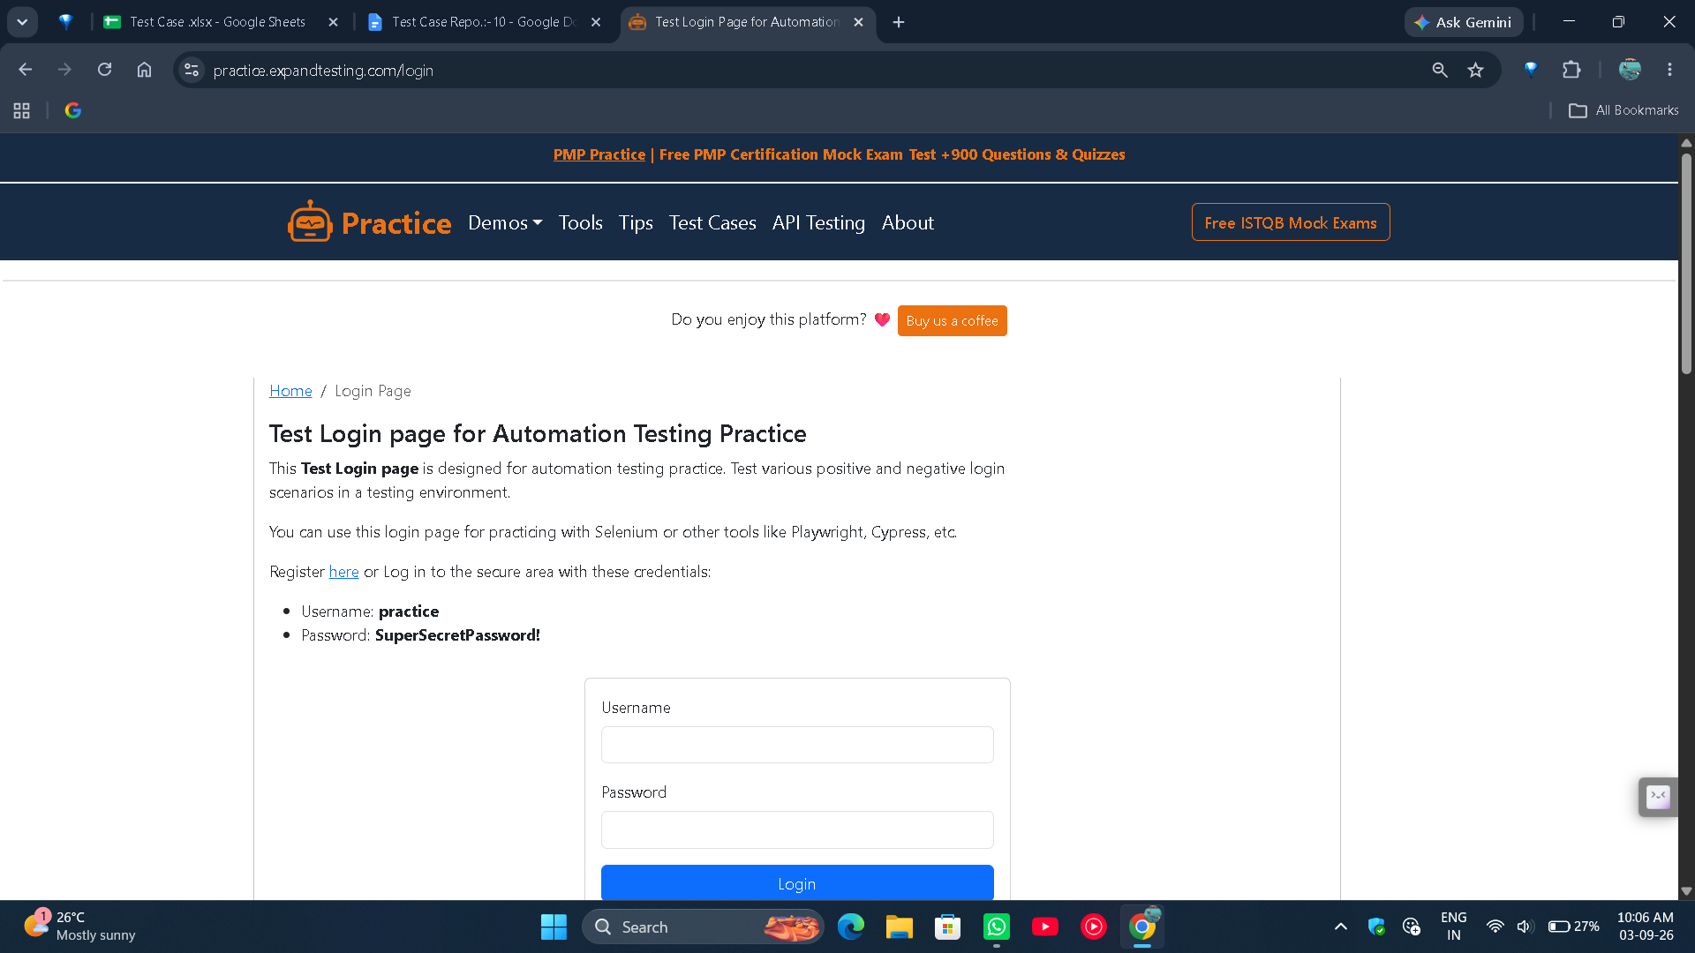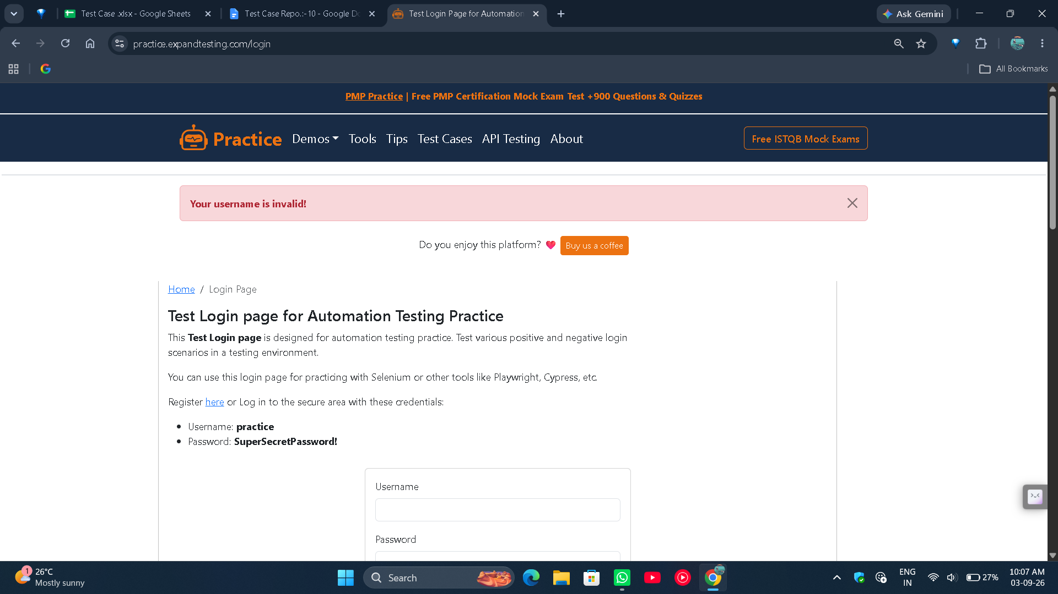

● Scenario ID: 10e
Scenario: Logout After Login
Test Steps:
- Open the Login page
- Login with valid credentials
- Click on the Logout button
Screenshots:-